VINTAGE VAULT
LOGBOOK UPDATE
WEEK 1-5
BMM

STUDENT DETAILS
- Student name – Brenda Mwelu
- Admission number- BBIT/2024/73868
- Course- Advanced Web Design and Development
- Unit code- BIT3208
- Lecturer name – Mr. Nyoro
- Semester- Semester 2, year 3

Contents
STUDENT DETAILS 1
PROJECT DETAILS 6
ONLINE PORTFOLIO 6
A)WEEK 1 7
XAMPP INSTALLATION 7

APACHE AND MySQL RUNNNING 7
LOCALHOST TEST 8
GITHUB PAGE 9

STUDENT REFLECTION 9
B)WEEK 2 10
WIREFRAMES AND GUI DESIGN 10
WIREFRAMES 10
GUI DESIGN 11
GITHUB PAGE 11
STUDENT REFLECTION 12
c) WEEK 3 13
JAVASCRIPT FORM VALIDATION 13
PASSWORD STRENGTH CHECKER 13
PHP SYNTAX PRACTICE 14
DATABASE CONNECTION SCRIPT 15

DYNAMIC USER INPUT HANDLING 16
GITHUB PAGE 17
STUDENT REFLECTION 17
D) WEEK 4 18
LOGIN PAGE WITH PHP AUNTHENTICATION 18
FOLDER STRUCTURE 18
USER DASHBOARD 19
ADMIN DASHBOARD 20
SERVER SIDE PHP PROCESSING 20
HTML FORMS, PHP INTEGRATION AND AUTHENTICATION 22
DATABASE CONNECTION SCRIPT 24
GITHUB PAGE 25

STUDENT REFLECTION 25
E) WEEK 5 26
PERFORMING OF CRUD OPERATIONS 26
DATABASE CONNECTION SCRIPT 27
GITHUB PAGE 27
STUDENT REFLECTION 28

PROJECT DETAILS
- Project title – VINTAGE VAULT
- Selected technologies – PHP +MySQL+ NGROK (DEPLOYMENT)

ONLINE PORTFOLIO
- GitHub repository – https://github.com/mutisobrenda8-dot/Vintage-Vault.git

- Deployment link - https://bubbly-jot-speckled.ngrok-free.dev/week1-brenda/week1b/

A)WEEK 1

XAMPP INSTALLATION

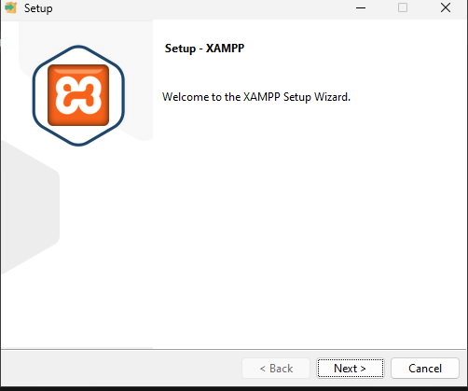-

- Fig.1 show the installation and setting up of XAMPP.

APACHE AND MySQL RUNNNING

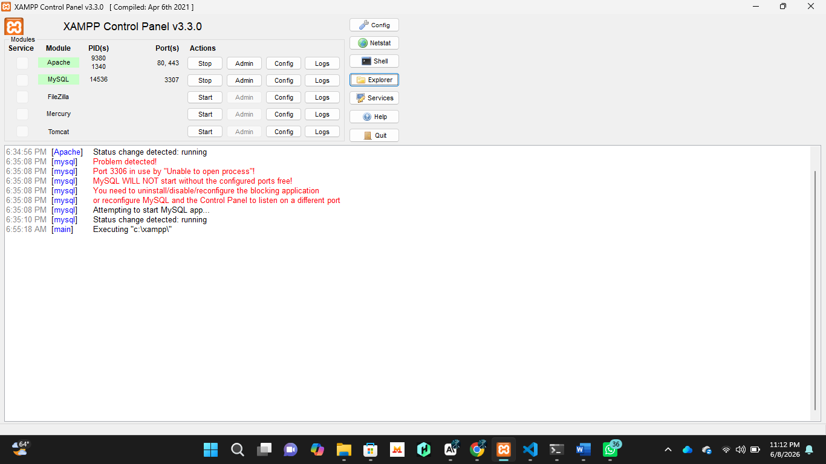
-Fig 2. Shows the successful running of Apache and MySQL in the Xampp control panel.

LOCALHOST TEST

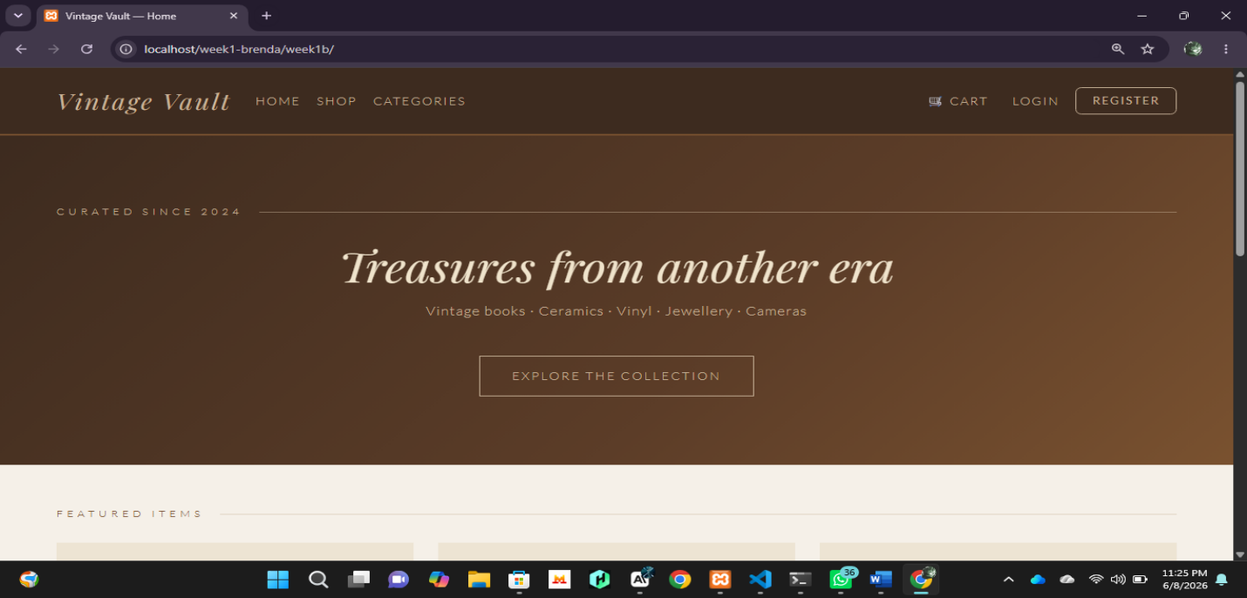
-Fig 3. Displays successful running of the localhost in the browser.

GITHUB PAGE

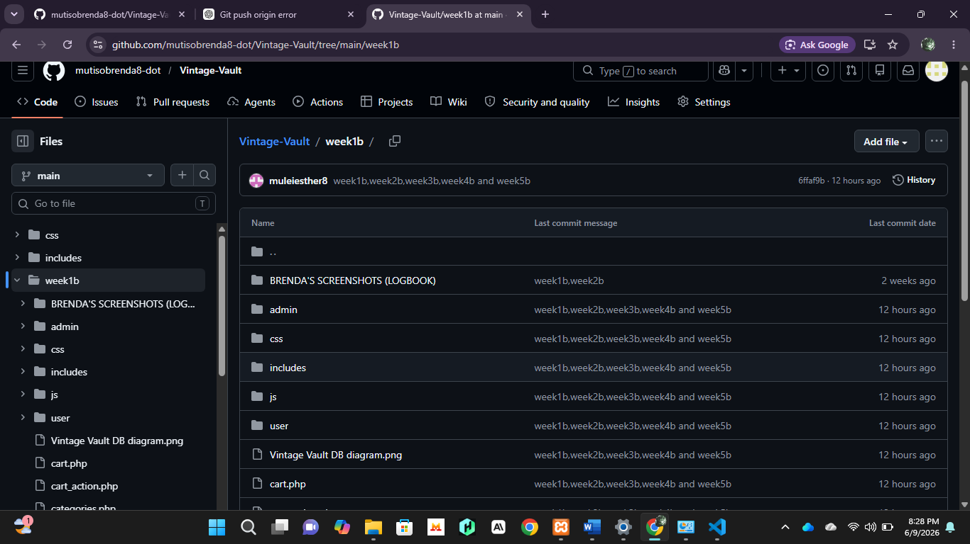

Fig 4. A view the GitHub page with the week 1 push.

STUDENT REFLECTION
-During Week 1, I successfully set up the development environment using XAMPP and configured Apache and MySQL services. The localhost test confirmed that the server was functioning correctly, while the GitHub screenshot demonstrates successful version control setup and project backup. One challenge was understanding the XAMPP configuration process, but testing localhost helped verify that the environment was ready for development. This week provided the foundation required for building the Vintage Vault system.

B)WEEK 2

WIREFRAMES AND GUI DESIGN

WIREFRAMES
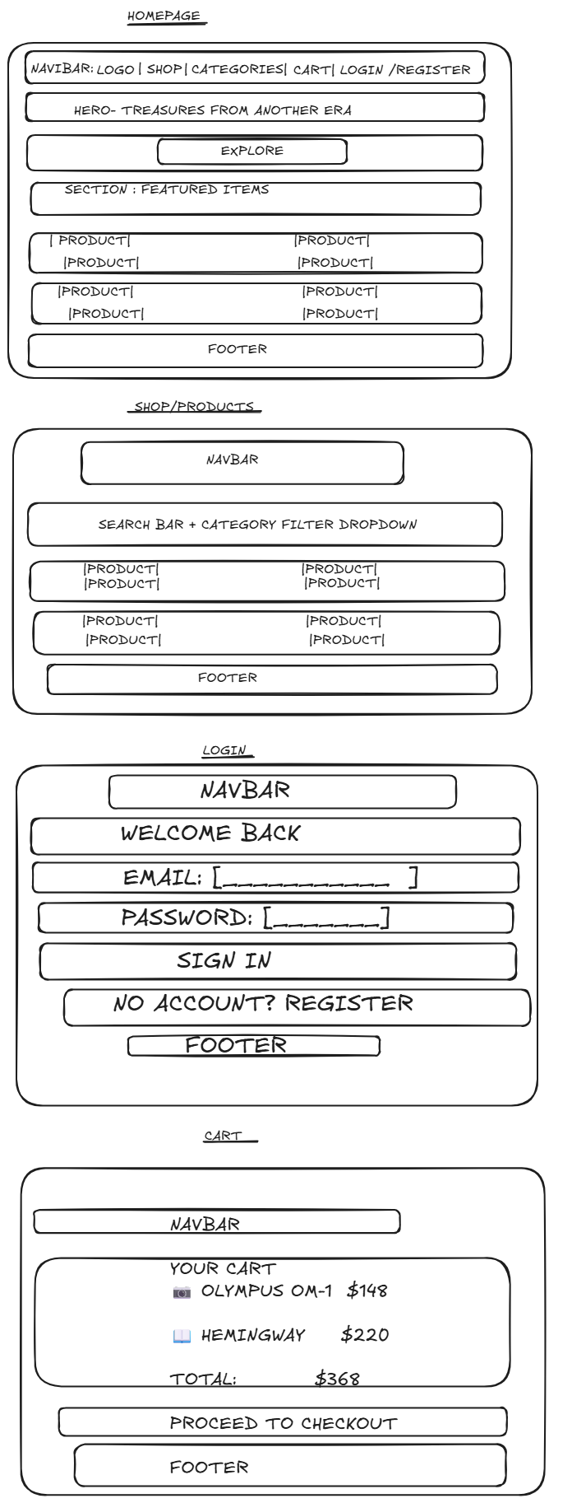

- HOMEPAGE

-SHOP/PRODUCTS PAGE

-LOGIN/REGISTER PAGE

-CART PAGE

GUI DESIGN

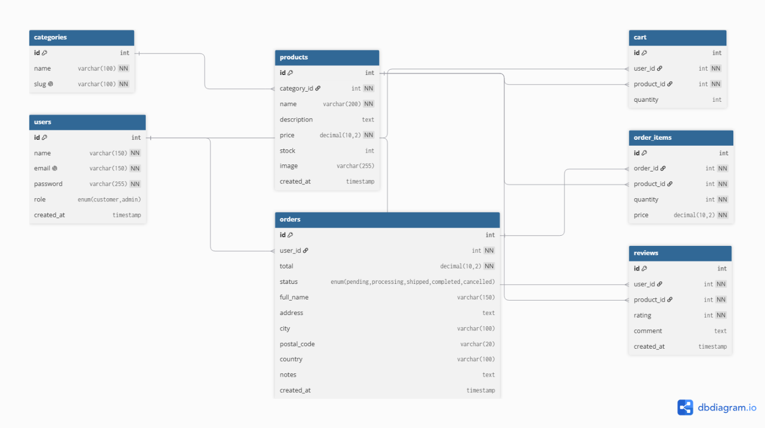

GITHUB PAGE

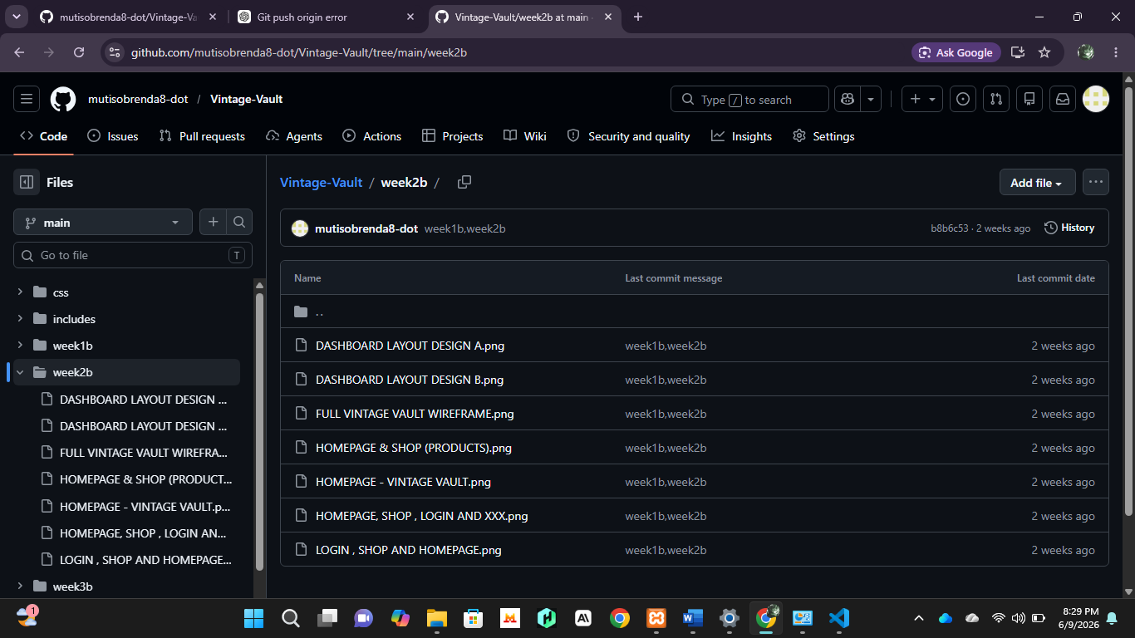
-Fig 1. Shows successful push of week 2 to GitHub

STUDENT REFLECTION
-This week focused on planning the user interface and system structure for Vintage Vault. I designed wireframes for the homepage, shop page, login/register page, and cart page using Exalidraw before implementation. The GUI design helped visualize how users would interact with the system and improved navigation planning. I considered user experience by organizing menus and pages logically to reduce unnecessary clicks. This design stage made development easier by providing a clear roadmap for the application's layout and functionality.

c) WEEK 3

JAVASCRIPT FORM VALIDATION

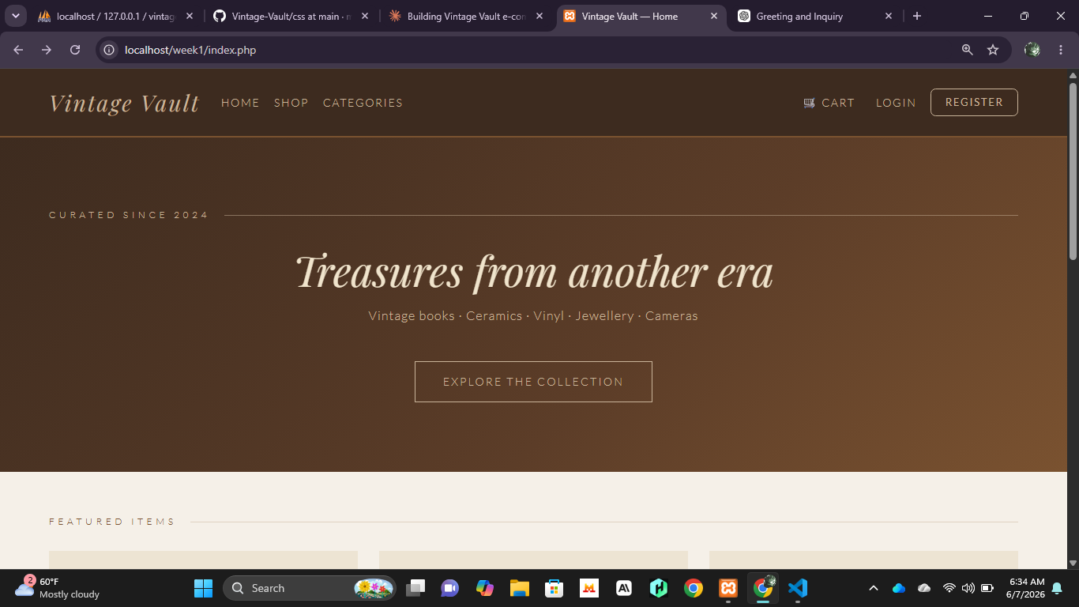

PASSWORD STRENGTH CHECKER
-Fig 2. Shows that the password is weak when creating a new account.

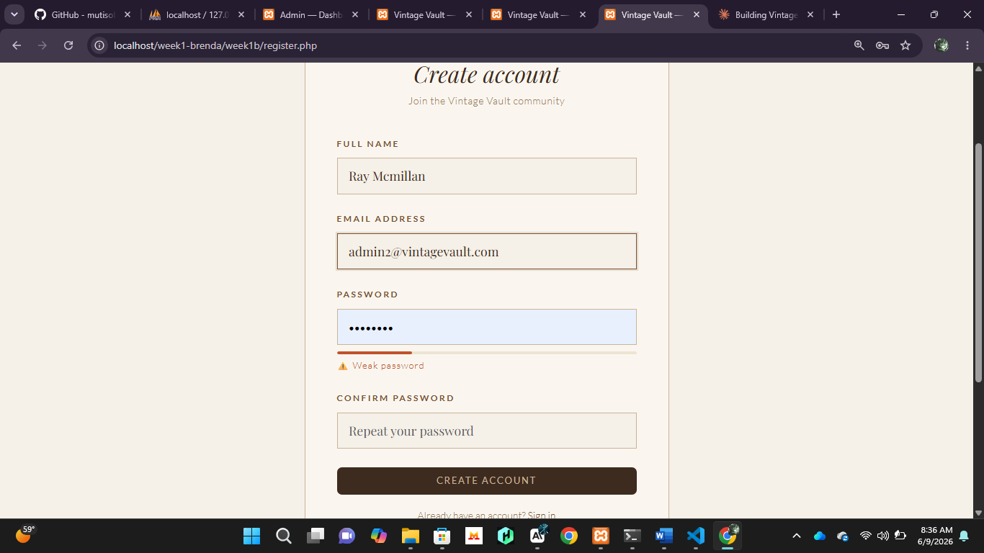
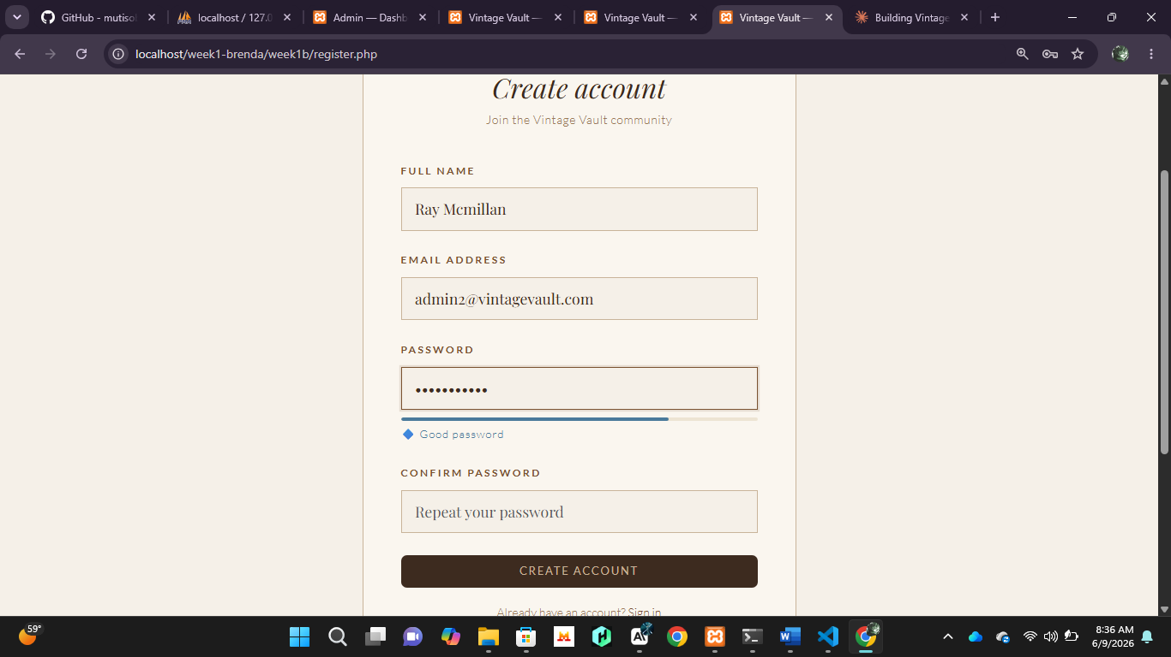

- Fig 3. Shows a strong and good password after changes.

PHP SYNTAX PRACTICE
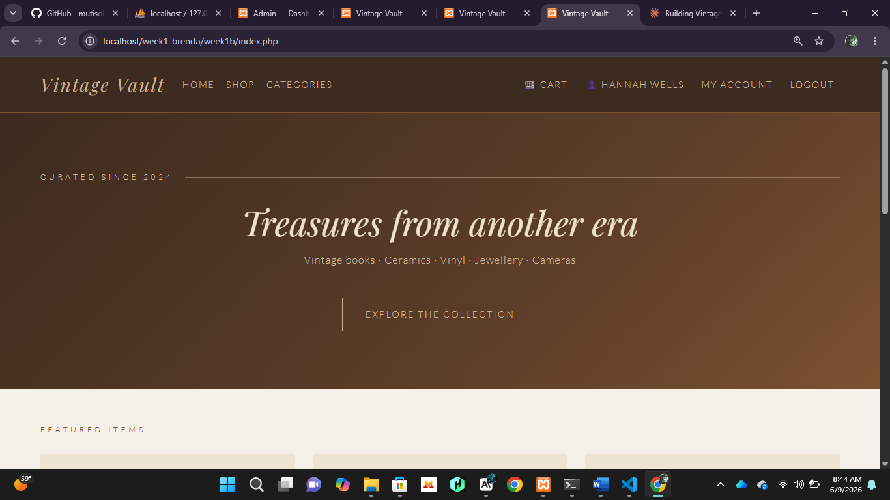
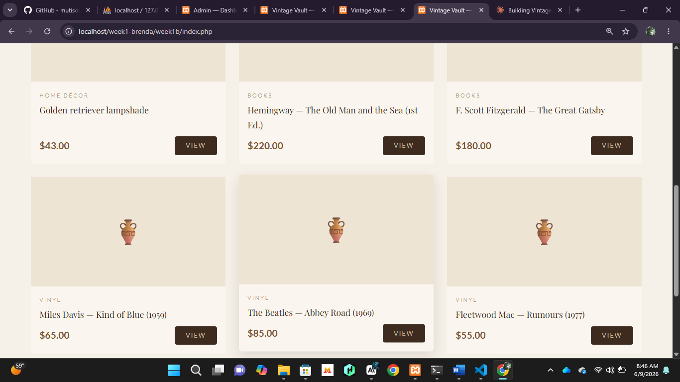
-Fig 4 & 5 show the successful working of the php syntax in the browser.

DATABASE CONNECTION SCRIPT

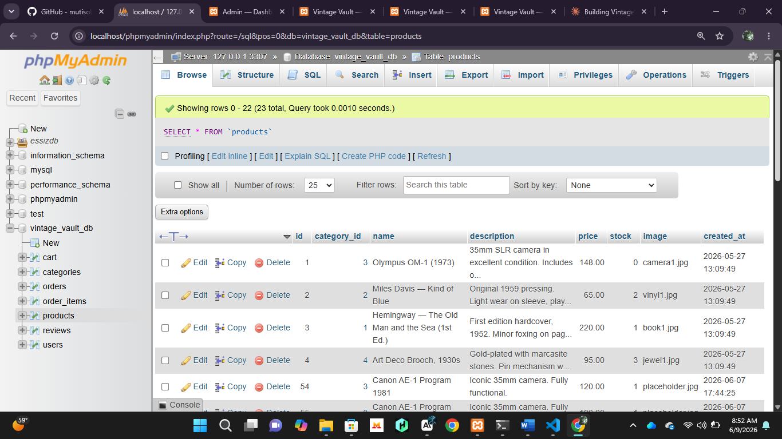
-Fig 6. Shows successful database connection.

DYNAMIC USER INPUT HANDLING
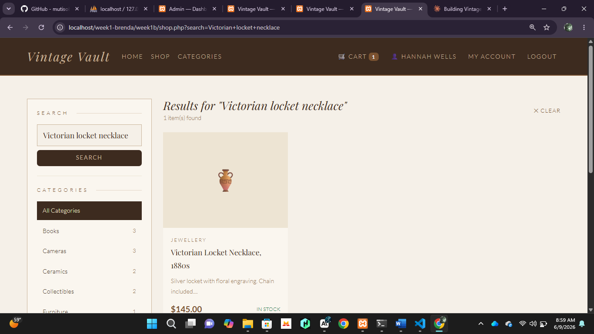
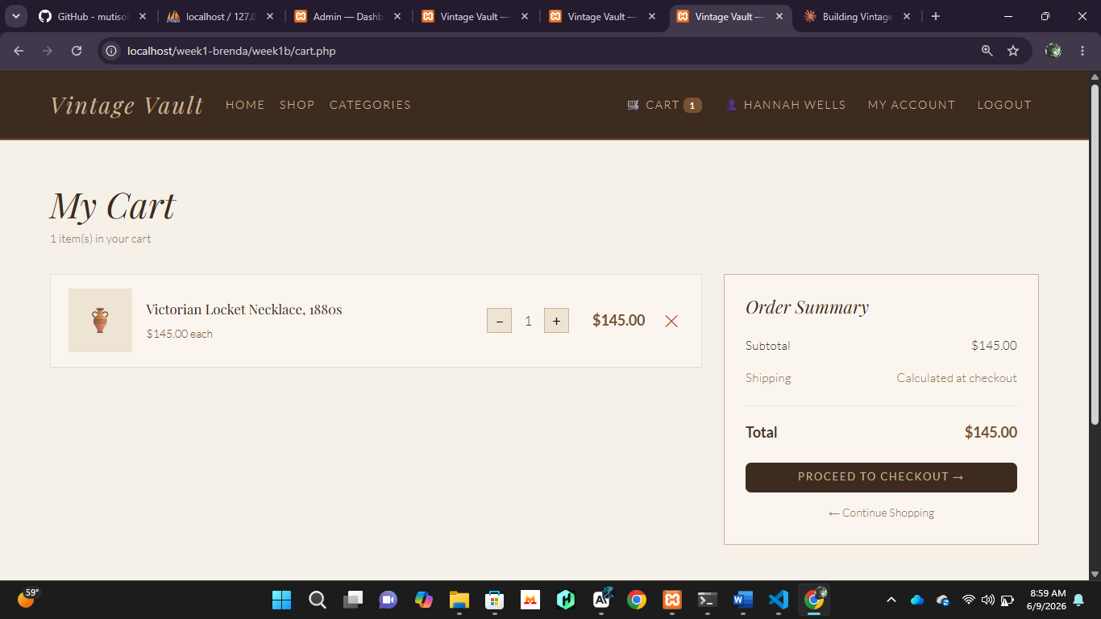
-Fig 7&8. Display the user searching for an item and adding it to the cart before proceeding to checkout.

GITHUB PAGE

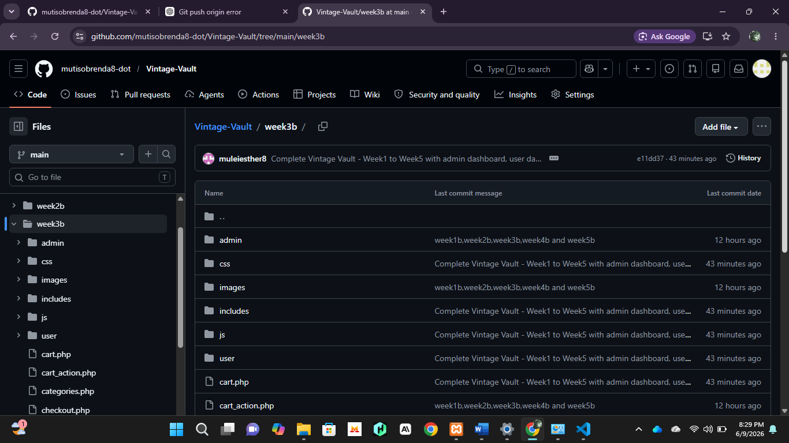
-Fig 9. Week 3 push to GitHub.

STUDENT REFLECTION
- I learned how JavaScript and PHP work together to improve user interaction and backend processing. JavaScript validation and the password strength checker helped ensure users enter valid information before submission. PHP syntax practice improved my understanding of server-side scripting, while the database connection confirmed successful communication between PHP and MySQL. Dynamic user input handling demonstrated how customers can search for products and interact with the shopping cart. The GitHub update shows continued project development and version control throughout the implementation process.

D) WEEK 4

LOGIN PAGE WITH PHP AUNTHENTICATION
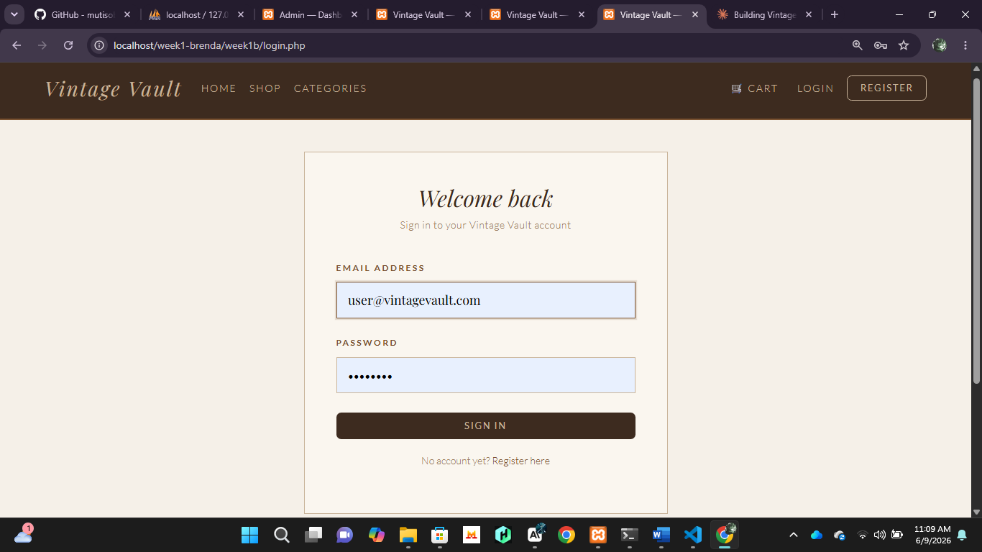
-Fig 1. Shows the login page (user).

FOLDER STRUCTURE
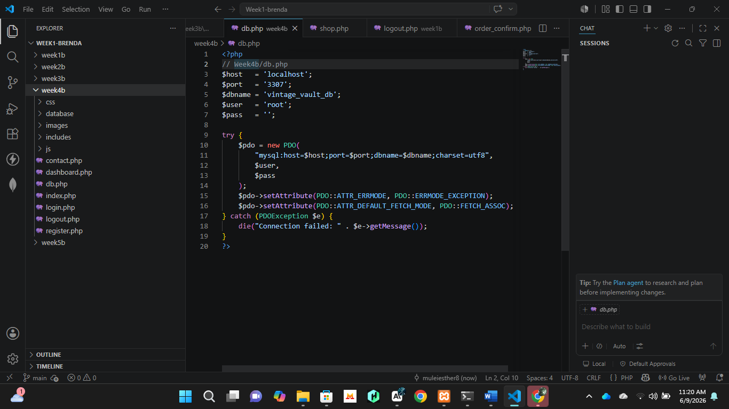
-Fig 2. Shows the folder structure for week 4.

USER DASHBOARD

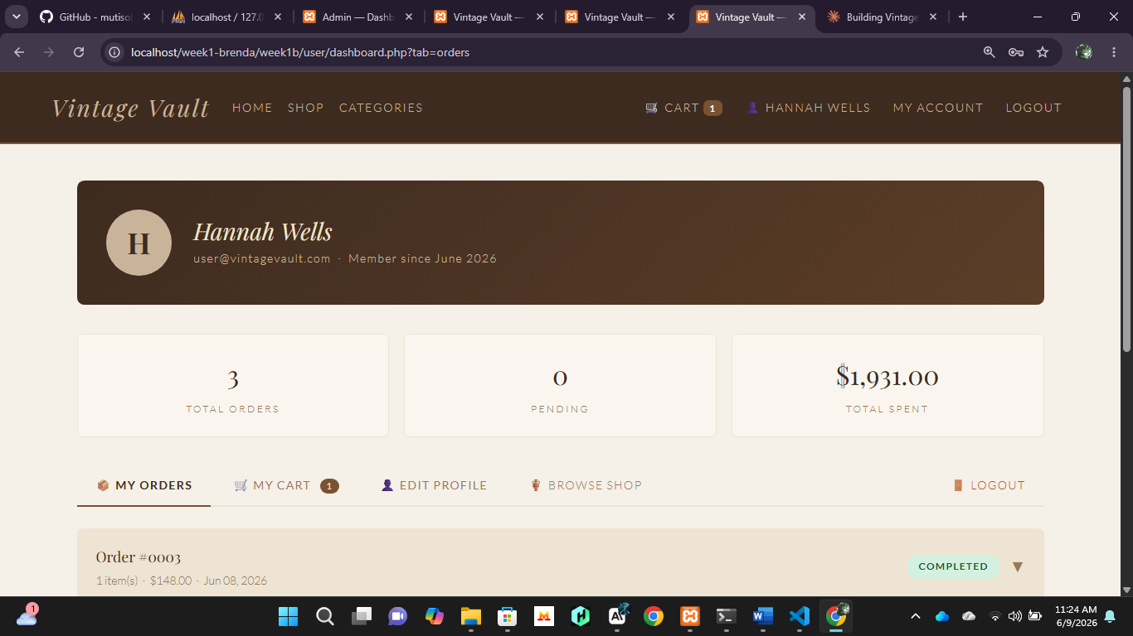
-Fig 3. Shows the user dashboard with the required tabs.

ADMIN DASHBOARD
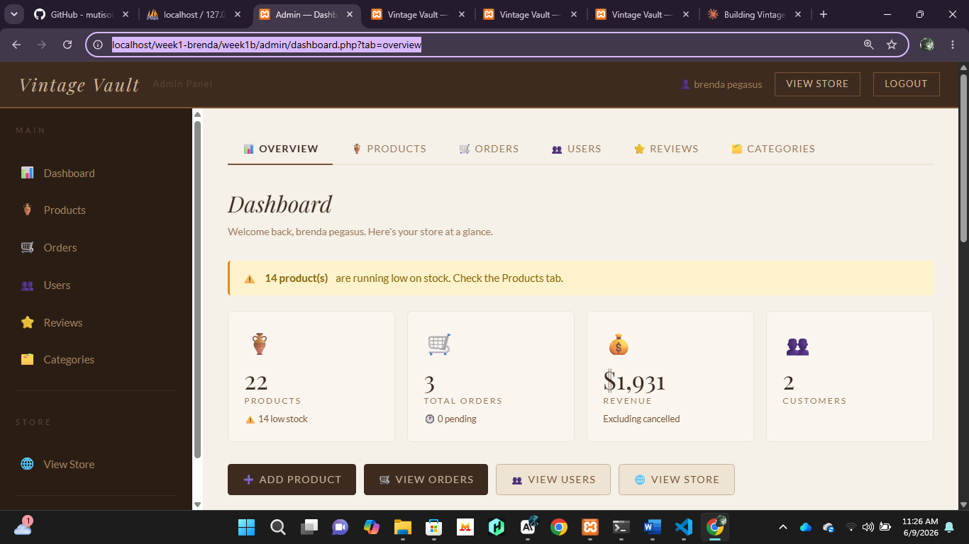
-Fig 4. Shows the user dashboard.

SERVER SIDE PHP PROCESSING
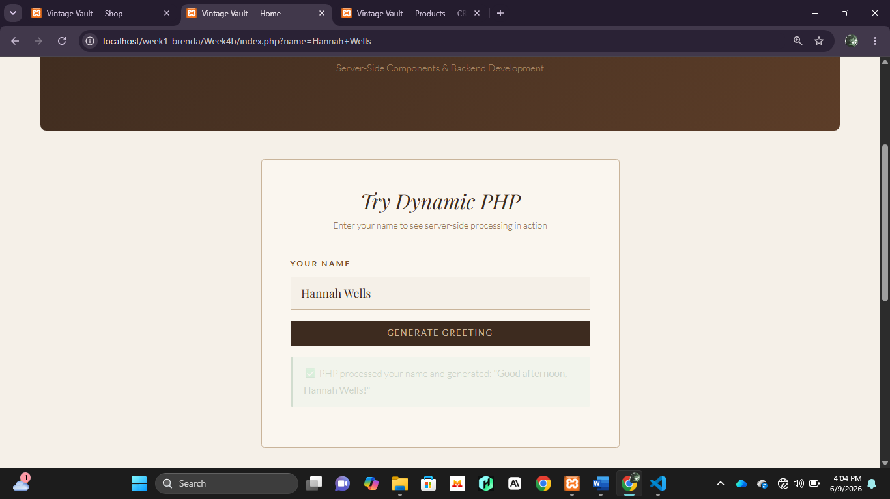
-Fig 5. Displays a demonstration of the server-side processing. The user/admin enters the name to generate a greeting.
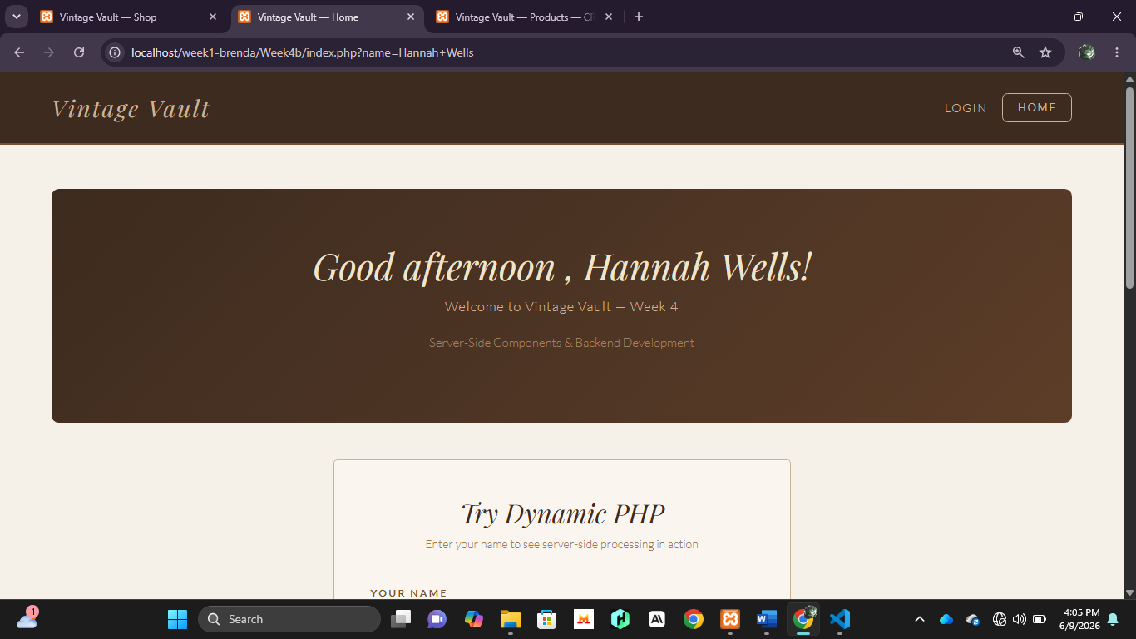
-Fig 6. Shows successful processing and the greeting is displayed at the top bar.

HTML FORMS, PHP INTEGRATION AND AUTHENTICATION
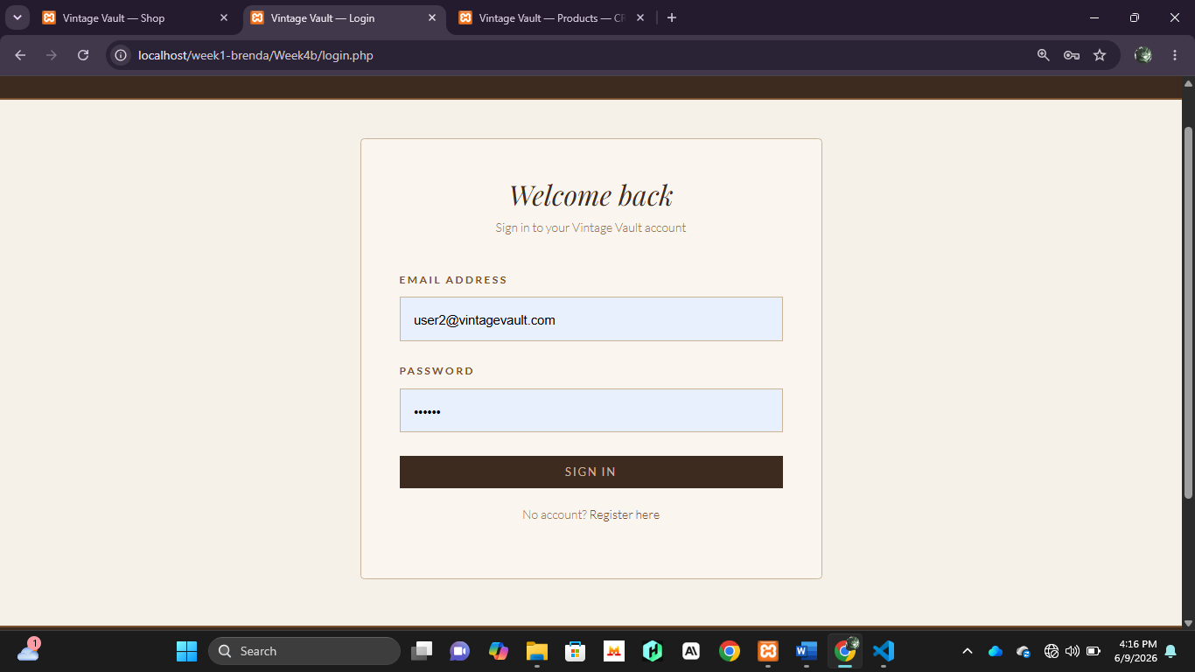
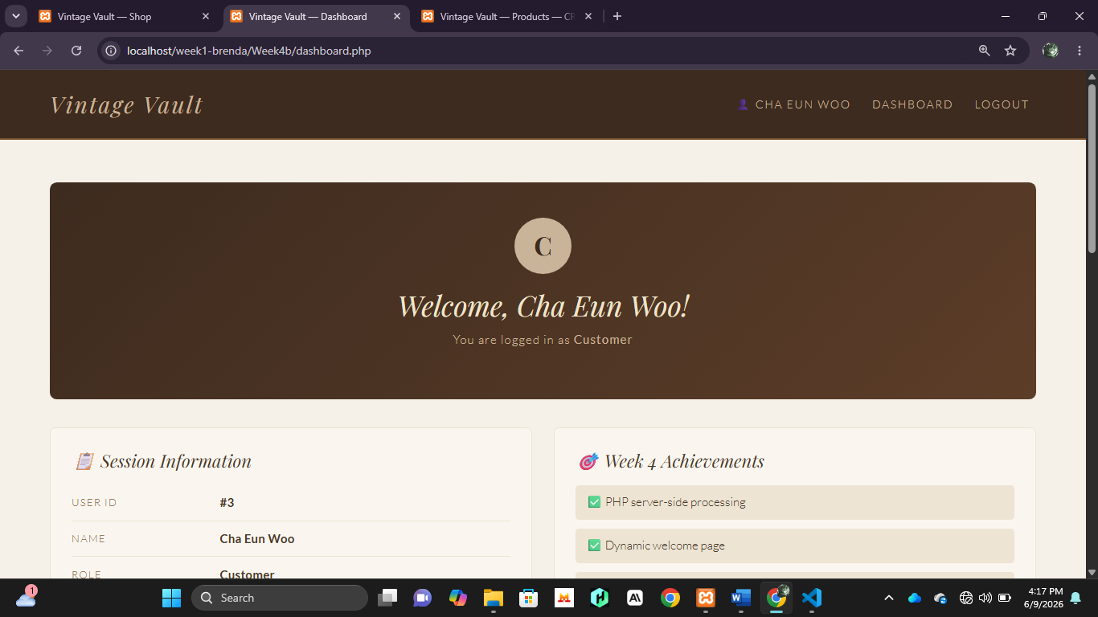
-Fig 7&8. Show the login page for processing the dynamic welcome page. In this case the user has logged in.
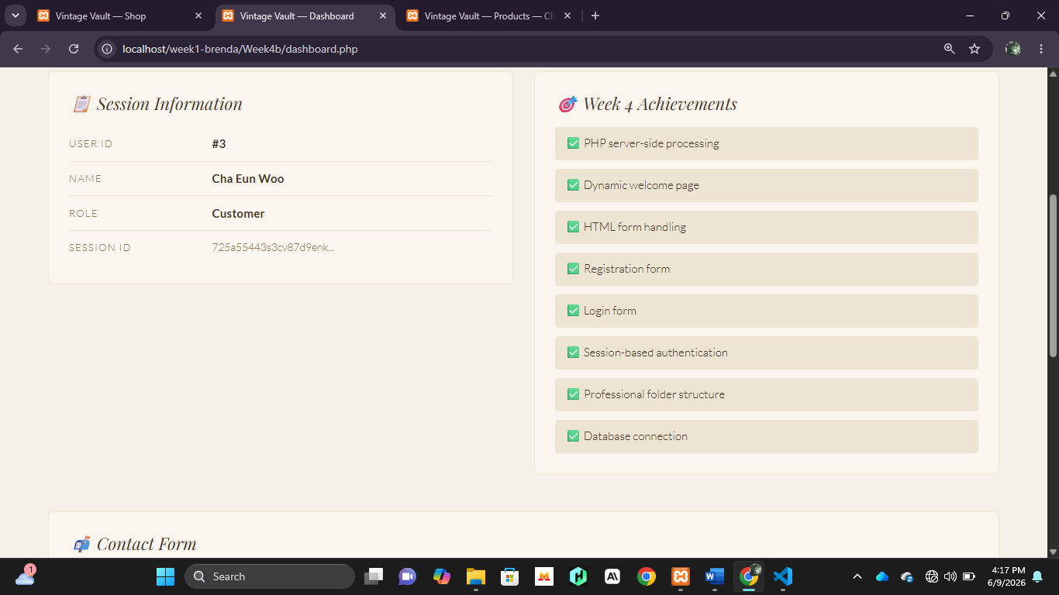
-Fig 9. Shows the session information with the necessary details alongside the weekly achievements.
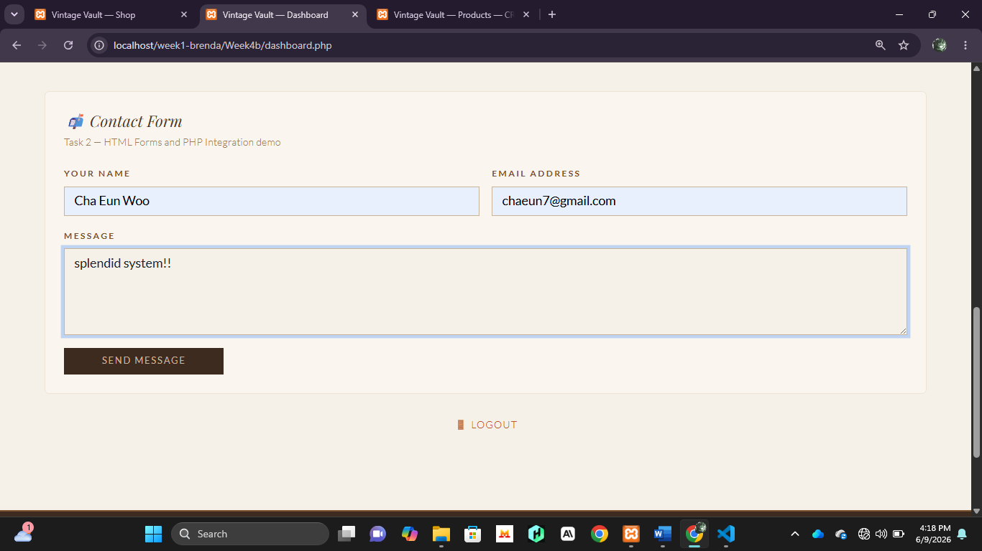
-Fig 10. Shows a basic HTML contact form demonstrating PHP integration.
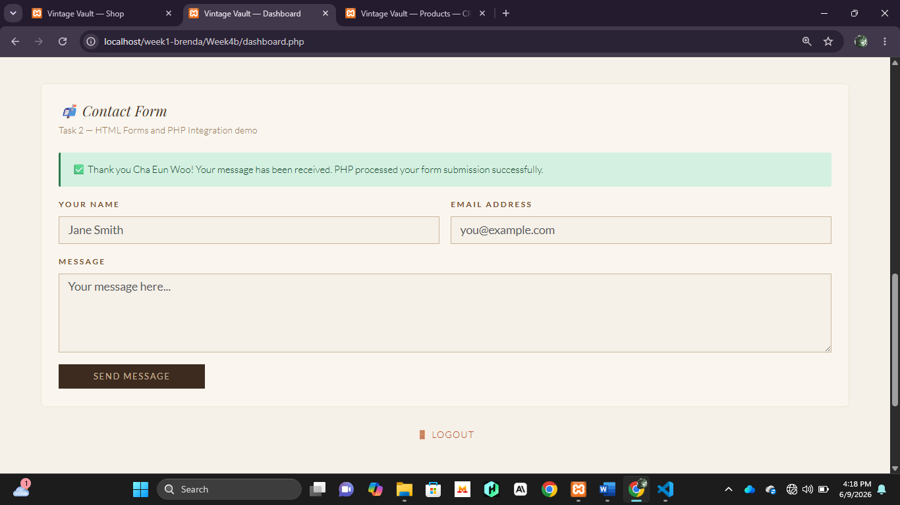
-Fig 11. Shows the result after a message and the details have been submitted.

DATABASE CONNECTION SCRIPT
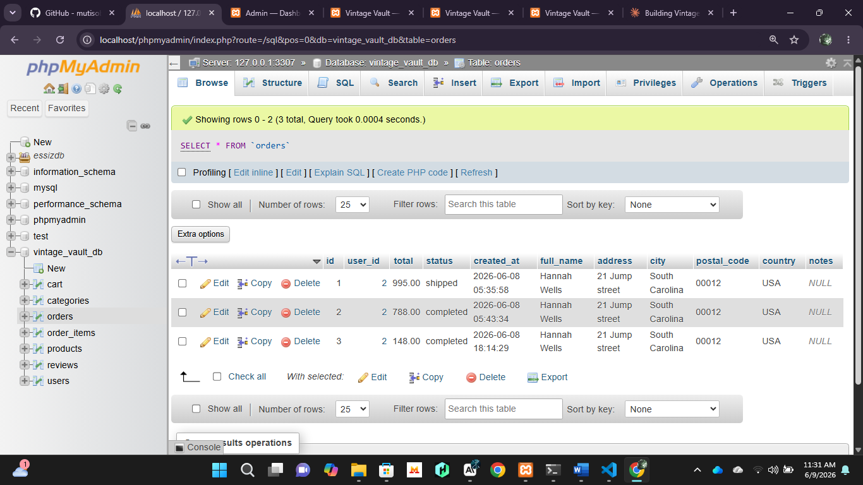
-Fig 5. Shows a successful database connection.

GITHUB PAGE

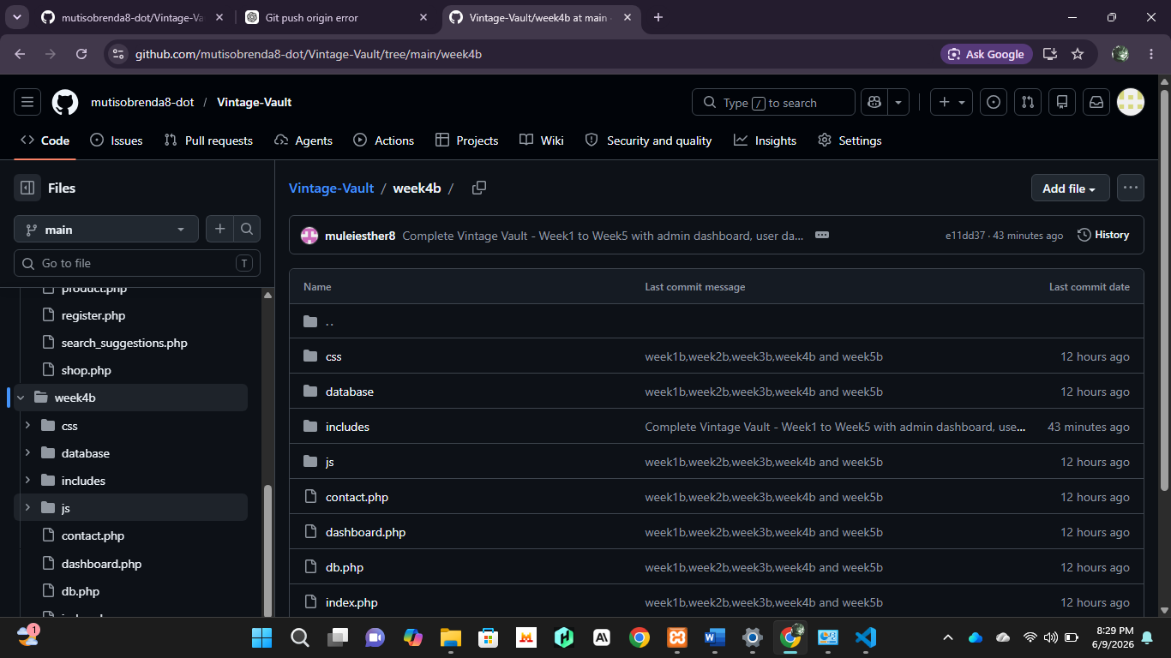
-Fig 6. Week 4 push to GitHub

STUDENT REFLECTION
-This week focused on authentication, dashboards, and server-side processing. I implemented user login functionality using PHP and created separate user and admin dashboards. I learned how sessions manage user information after successful login. The server-side processing demonstrations showed how PHP can process and display dynamic data. I also integrated HTML forms with PHP and tested database connectivity. One challenge was organizing the project structure and ensuring user sessions worked correctly.

E) WEEK 5

PERFORMING OF CRUD OPERATIONS
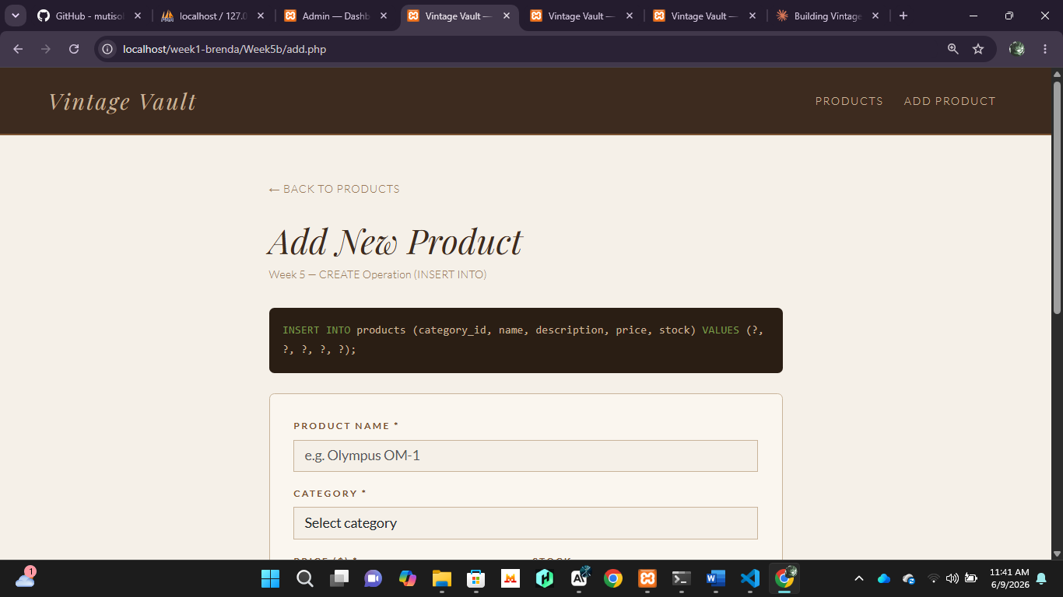
-Fig 1. Shows the page that demonstrates how the admin can add(create) a product which reflects back to the database.
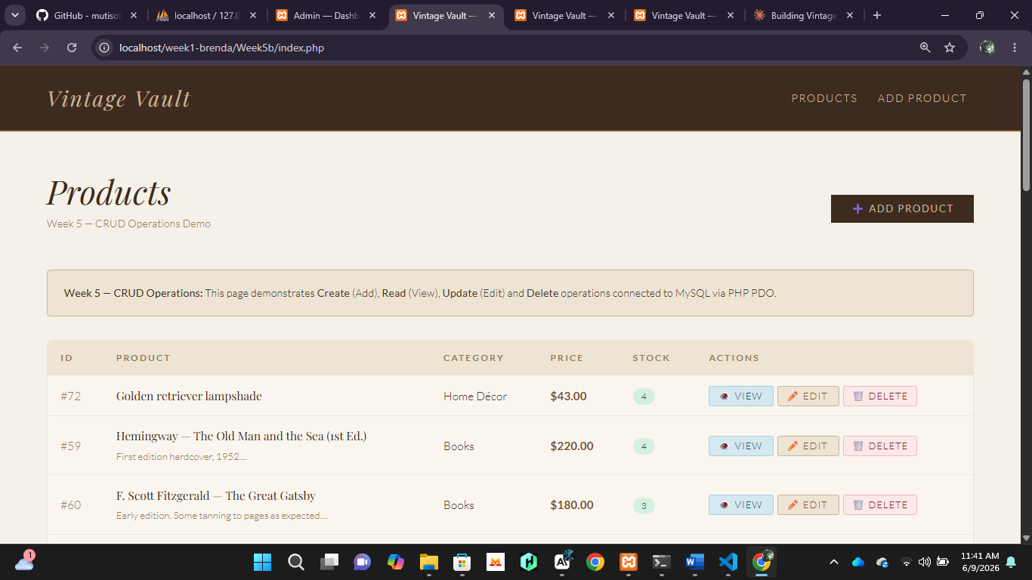
-Fig 2. Shows the second page where the other CRUD functions can be applied i.e., Read, Update and Delete.

DATABASE CONNECTION SCRIPT
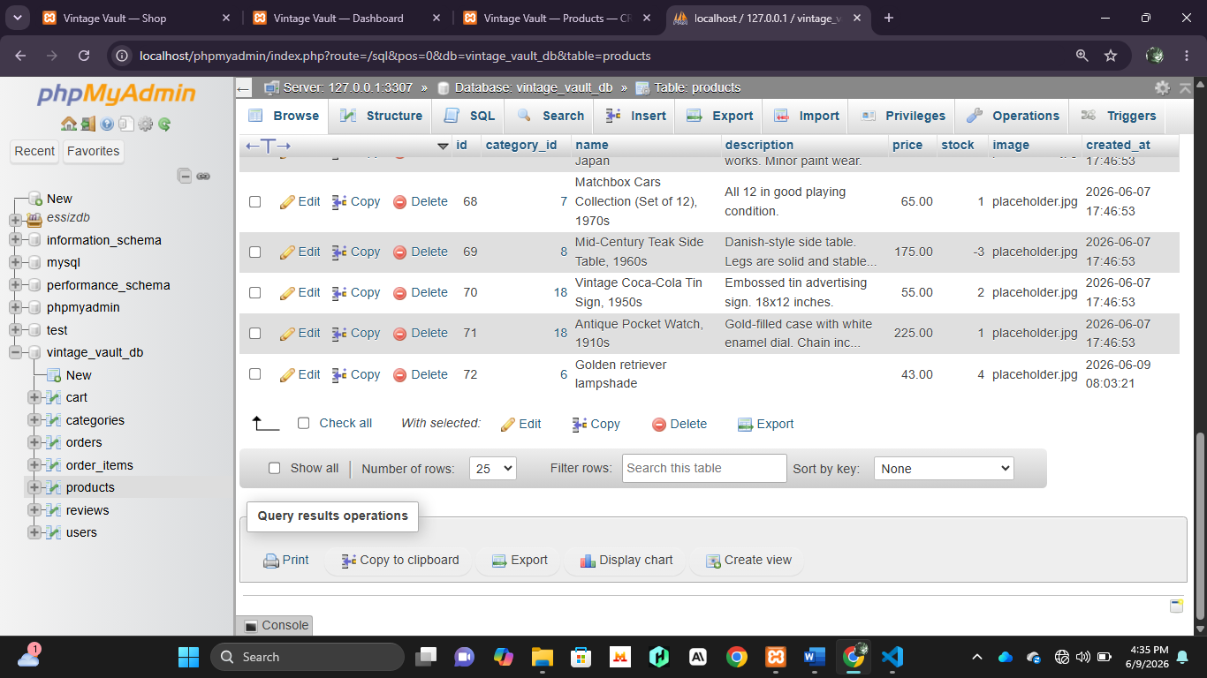
-Fig 3. Shows a successful database connection

GITHUB PAGE
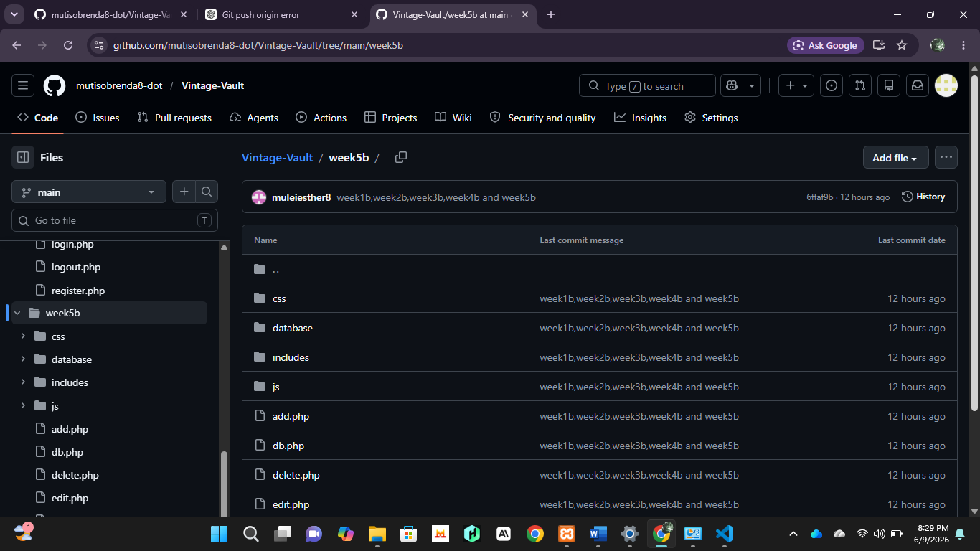

-Fig 4. Successful week 5 push to GitHub.

STUDENT REFLECTION
-I implemented CRUD operations for product management within the Vintage Vault system. I learned how administrators can create, read, update, and delete product records stored in the database. The database connection script ensured reliable communication between PHP and MySQL during these operations. Testing CRUD functionality improved my understanding of backend development and database management. One challenge was ensuring that changes made through the admin interface were reflected correctly in the database.

